RELIEF 12-03

Draft Report

6 June 2012

John Crowley

Information Sharing Analyst (contractor)

TIDES

Center for Technology and National Security Policy

National Defense University

Dr. Linton Wells II

Director

Center for Technology and National Security Policy

National Defense University

Sam Bendett

Research Associate

Center for Technology and National Security Policy

National Defense University

# Introduction

The eleventh meeting of the Research and Experimentation for Local and International First Responders (RELIEF) experiments took place from 21-23 May 2012 at the National Defense University in Washington, DC. Over 60 people from 33 organizations in the disaster response community participated in crowdsourced and tabletop experiments.

# Key Successes

* **Tested Crowdsourcing of the Analysis of NEXTVIEW Satellite Imagery**: Performed a performance test on the first official workflow of government-owned commercial imagery to a crowdsourcing organization under the NEXTVIEW imagery license. 32 volunteer cartographers from OpenStreetMap put 10 refugee camps in Ethiopia and Kenya on the map, representing approximately 600,000 refugees.
* **Designed Methods for Crowdsourcing the Analysis of Civil Air Patrol Imagery**: FEMA asked for means to accelerate the tasking, collection, and analysis of imagery from Civil Air Patrol. Experts at RELIEF designed five methods that will be explored in August with FEMA and CAP.
* **Explored Alternative Pathways for Unclassified Information Sharing**: Government approaches to sharing information across agencies and with external partners has centered on the use outdated and ineffective web portals—a practice that requires intensive and expensive human labor to read and make sense of accelerating information flows. Experts explored web services architectures for federating data exchange and using machine to filter and analyze big data.

# Participating Organizations

* Air National Guard
* American Red Cross
* Army Geospatial Center
* Cultural Knowledge Consortium
* DHS FEMA
* DigitalGlobe
* ESRI
* FEMA
* G&H International
* GeoEye
* GeoIQ
* George Mason University
* George Washington University
* Global VSAT Forum
* Humanitarian OSM Team
* IST Research
* Medweb
* Naval Postgraduate School
* NGA
* NowForce
* NPS Remote Sensing Center
* Pacific Disaster Center
* Potomac Institute
* Robert Baker
* TIDES
* TRADOC G2, HTS
* U.S. Department of State
* U.S. Geological Survey
* USAID
* Wilson Center
* Woodrow Wilson Center
* World-Wide Human Geography Data Working Group

# Tracks

Work during the experiment occurred within four planned tracks. Each track and experiment is explained in detail in the sections that follow.

1. **Mapping:** *Testing the NEXTVIEW/Camp Roberts imagery workflow process* (State Department Humanitarian Information Unit (HIU) and Humanitarian OpenStreetMap Team (HOT))
2. **Imagery Collection and Processing.** *Accelerating processing of imagery collected by Civil Air Patrol with crowdsourcing* (FEMA)
3. **Interagency and Partner Unclassified Information Sharing.** *Exploring practical information sharing practices in UISS* (OSD, DISA, State Public Diplomacy, Secretariat, HIU, and eDiplomacy)
4. **Planning for August RELIEF 12-04 at Camp Roberts.** Creating the plan for the largest experimentation program at RELIEF since its inception.

# Track 2: Mapping

For the past six RELIEF experiments, NGA and the US State Department have been exploring how to release commercial imagery purchased by the US Government to volunteer geographic organizations like OpenStreetMap, so that volunteers could trace features and “densify” the map. During RELIEF 12-03, the team tested this workflow for the first time, releasing imagery from 10 refugee camps in Ethiopia (Dollo Ado) and Kenya (Dadaab) to be traced by the Humanitarian OpenStreetMap Team.

## Area of Interest (AOI)

The AOI was a famine-affected area of the Horn of Africa, where refugees have been massed into camps of different ages and sizes.

### Ethiopia

There are five separate camps within the Dollo Ado area, with 151,972 individuals / 36,721 households living there (Cf. [UNHCR data portal for the Horn of Africa](http://data.unhcr.org/horn-of-africa/regional.php), and the [22 May 2012 Dollo Ado population statistical report](http://data.unhcr.org/horn-of-africa/download.php?id=901.pdf&name=Dollo%20Ado%20Population%20Statistics%202012%20May%2022.pdf)). Many of these camps are newer than those in Kenya and therefore smaller:

1. **Bokolmanyo** – 39,196 individuals – 9,815 households  
   ([Tasking Server](http://tasks.hotosm.org/job/34)) ([OSM map](http://bit.ly/JxCjpj)) ( 13 x 13 squares )
2. **Melkadida** – 40,621 individuals – 9,303 households  
   ([Tasking Server](http://tasks.hotosm.org/job/35)) ([OSM map](http://bit.ly/LyyEJX)) ( 15 x 16 squares)
3. **Kobe** – 26,695 individuals – 6,370 households  
   ([Tasking Server](http://tasks.hotosm.org/job/35)) ([OSM map](http://bit.ly/JhmkKF)) (bunched with Melkadida)
4. **Helawein** – 26,463 individuals – 6,400 households  
   ([Tasking Server](http://tasks.hotosm.org/job/36)) ([OSM map](http://bit.ly/Ko8lp5)) ( 11 x 8 squares )
5. **Buramino** – 18,997 individuals – 4,833 households  
   ([Tasking Server](http://tasks.hotosm.org/job/37) — Task Completed!) ([OSM map](http://bit.ly/JhmB0d))

### Kenya

There are also five camps in the Dadaab area, with 465,334 individuals living there ([UNHCR 20 May 2012 Dadaab population statistical report](http://data.unhcr.org/horn-of-africa/download.php?id=897.pdf&name=Dadaab%20Demographic%20Statistics%20-%2020May2012.pdf)).

1. **Dagahaley** – 123,493 individuals – 36,041 households  
   ([Tasking Server](http://tasks.hotosm.org/job/38)) ([OSM map](http://bit.ly/KGdaa3)) ( 13 x 10)
2. **Ifo 2** – 73,019 individuals – 18,723 households  
   ([Tasking Server](http://tasks.hotosm.org/job/39)) ([OSM map](http://bit.ly/KQlOIP)) (9 x 20 squares)
3. **Ifo** – 117,146 individuals – 38,365 households  
   ([Tasking Server](http://tasks.hotosm.org/job/40)) ([OSM map](http://bit.ly/KoeSQx)) ( 9 x 7 squares)
4. **Hagadera** – 138,269 individuals – 43,878 households  
   ([Tasking Server](http://tasks.hotosm.org/job/41)) ([OSM map](http://bit.ly/MMOKBS)) (untasked by imagery was available)
5. **Kambioos** – 13,407 individuals – 2,813 households  
   ([Tasking Server](http://tasks.hotosm.org/job/41)) ([OSM map](http://bit.ly/KGdEwO)) (bunched with Hagadera and Ifo 2)

## Experimental Method/Design

The experiment was designed to test the baseline capacity of the Humanitarian OpenStreetMap team, as opposed to the surge capacity, which might be available during a major capacity; volunteer participation would be about an order of magnitude larger than pool of volunteers that participated in RELIEF 12-03). Advertising was kept to a minimum: the team made several tweets and a blog post on the hot.openstreetmap.org web site three days before the test.

Instead of mobilizing volunteers with defined tasks, the partners opted to test the capacity of the new HOT Tasking Manager to allow self-organized behavior. The Taksing Manager is a piece of software (developed with funding from the Australian-Indonesia Facility for Disaster Reduction (AIFDR)) that allows volunteers to “check out” grid squares from the map and either complete the task or unlock it so another volunteer can work on the area. The Tasking Manager also has an audit capacity, so other mappers can examine the quality of the work of an original set of mappers, edit that work, and mark the grid square as “audited.” Figure one has red squares as completed tasks waiting to be audited, and green squares to mark squares where the audit has been completed:

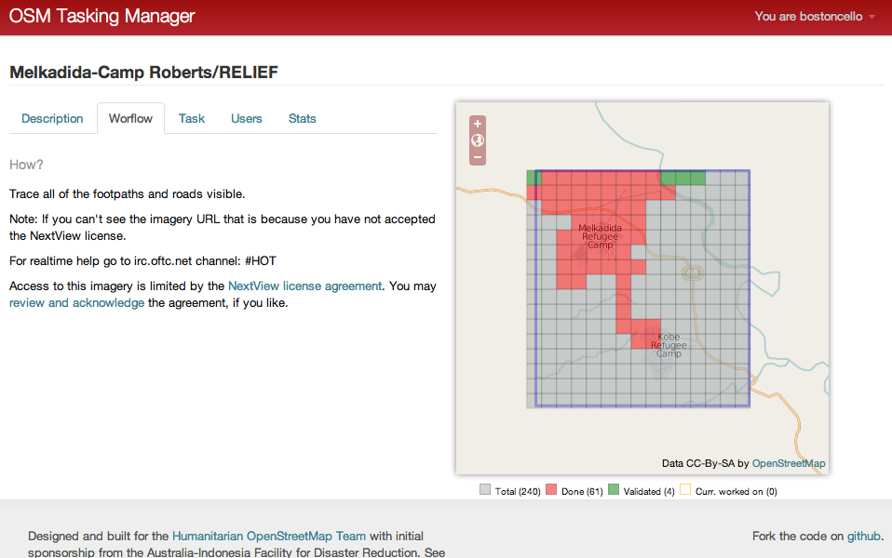

When a volunteer checked out a grid square, the imagery became available to them under the NEXTVIEW license, which was deemed by NGA and State Department lawyers to be compatible with the OpenStreetMap license (the Open Database License or ODBL; this interpretation was built over the course of several previous RELIEF experiments and subsequent internal USG discussions.

Imagery that was checked out was made available via web mapping service (WMS), so that the volunteer could trace the imagery either in the web browser or with a GIS tool, which included Quantum GIS and ESRI’s ArcMap with the free OpenStreetMap plugin.

*Figure (x): Imagery in Java OpenStreetMap Editor (JOSM) from the Bolkomanyo refugee camp*

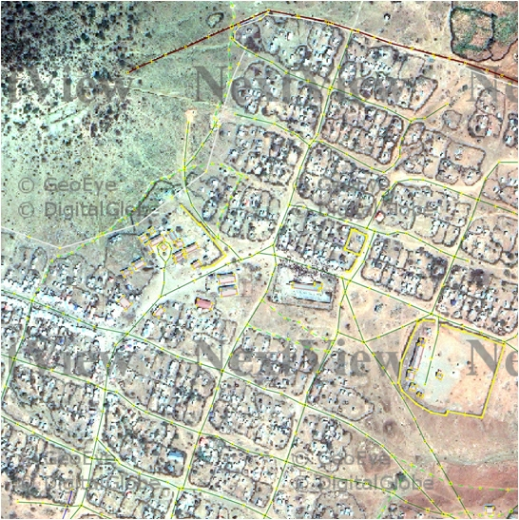

## Results

Over the course of 48 hours, 32 volunteers were asked to turn similar imagery across 10 camps into maps of the main footpaths and roads. Many volunteers went beyond this mission, tracing buildings and other structures within the camps, along with many of the footpaths that surround and connect the camps. Tracing continued after the experiment, and continues even at the time of this report.

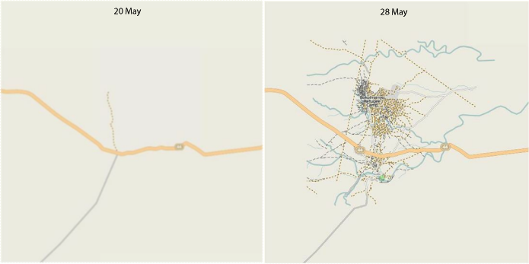

The level of detail of the footpaths and structures from the Melkadida refugee camp was astonishing:

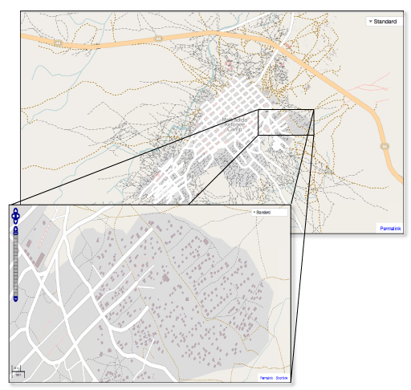

The State Department HIU and HOT are building a comprehensive analysis of the metrics for volunteer mapping, which will be released over the summer. Readers may wish to click on the links to OpenStreetMap from the camps listed above to track ongoing process that volunteers are making around the released imagery.

**The key takeaway from the experience**: when the USG releases imagery, there exists a powerful, free capacity to turn that imagery into maps that can be used for as a base map for logistics, planning, and humanitarian operations.

# Track 2: Imagery Collection and Processing

After a major emergency, responders at local, state, and federal agencies need to quickly acquire situational awareness within the first 6-12 hours. While satellite imagery is a critical resource, it generally takes more than 24 hours to collect, process, and release pixels that are taken from space. In contrast, the first imagery to be available is collected by the Civil Air Patrol using handheld SLR cameras. However, this imagery is often taken without a targeted collection plan. In addition, imagery is often shot at oblique angles and cannot be easily turned into a composite picture of the area of interest (AOI).

After seeing the success of the imagery workflow process that NGA and State/HIU had worked out with the Humanitarian OpenStreetMap Team at Camp Roberts, FEMA approached TIDES to ask if there might be a way to accelerate the workflow by which the Civil Air Patrol tasks, collects, and processes its imagery using crowdsourcing. TIDES agreed to host an initial conversation at RELIEF 12-03, followed by a technical brainstorming session and experiments that would explore the outputs from this conversation at Camp Roberts in August.

When the team started the discussion, RELIEF expected to design a process for teaching CAP to use crowdsourcing techniques to process its own imagery and turn those composite images into damage polygons. After three hours of brainstorming and analysis, and subsequent thinking over the next two days, the team developed five approaches to accelerating the way that CAP collects, processes, and analyzes imagery after a major disaster:  
  
1. **Better Collection Plans**: Building tools to focus CAP on the places that need to be imaged first, and dynamically changing those taskings based on incoming data, including reports from social media.  
  
2. **Nadir Camera Mounts**: most CAP images are obliques and less useful for building base maps than downward nadir imagery. RELIEF will work with NGA to investigate low-cost mounts that might be used by CAP, perhaps even including DIY mounts that could be put out as a design which local squadrons can build on.  
  
3. **Automated Photogrammetry**: software exists in the scientific literature indicating that is is possible to automate some imagery processing by CAP (Cf.   
<http://www.ipb.uni-bonn.de/fileadmin/publication/papers/2006/laebe06.automatic.pdf>). RELIEF will explore other potential unclassified and open-source tools, so that imagery can be quickly released into the public domain.  
  
4. **Crowd-based Mosaicking**. Work by MIT and the Public Laboratory for Open Technology and Science (PLOTS) has created software called MapKnitter, which allows crowds to rapidly stitch together individual images into a mosaic. This tool could be adapted and trained to members of CAP's 60K-person membership. RELIEF will explore this and similar tools and techniques, as well as potential curriculum for CAP.  
  
5. **Crowd-based Generation of Damage Polygons**. Building the official damage polygons is an NGA function. However, members of CAP may be able to draw initial sketches of the polygons based on their imagery and hand them directly to the local ICS commander. RELIEF will explore the policy and technical issues around accelerating the rate at which responders can generate initial damage polygons, potentially linking imagery with social media analysis.

Figure (x) captures the concept of operations for the August explorations:



The August exploration of these five concepts will harness the resources of the Center for Interdisciplinary Remotely-Piloted Aircraft Studies (CIRPAS) program at NPS, which has built a Predator surrogate called a Pelican. This highly modified Cessna 337 Skymaster has a complete Predator A optical package with the Electro-Optical and Infrared cameras along with the live video camera mounted in a skyball. The Pelican has a ground station with a live data link. The aircraft will also accommodate experimental camera mounts without need of acquiring special permissions that would necessary to test these mounts on CAP aircraft. RELIEF plan to test as much of the five explorations as technology, time, and weather permit from 13-17 August using the Predator aircraft (along with any CAP aircraft that wish to participate).

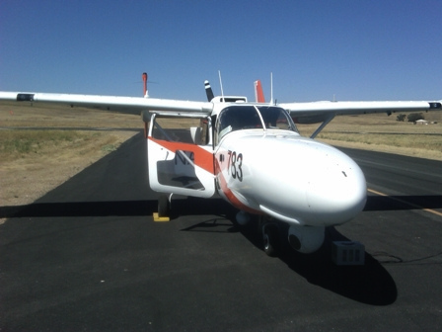

# Track 3: Unclassified Information Sharing

In any context, coordinated action requires communication. When disasters degrade or destroy communications networks and thousands of organizations descend into a country, coordination can become more an aspiration than accepted practice. To make matters worse, after Wikileaks, USG interagency information sharing is marked more by distrust and disconnection than by open exchange of information.

The dominant method of addressing this problem has been for each agency to build web portals with careful controls over who can get access to the resources. This architecture sets up the expectation that the hundreds of organizations that are external partners with the USG will use USG web portals to interact with USG agencies. While this approach has a certain logic, experts at RELIEF examined the issues that prevent this architecture from being effective:

1. **Information Overload**. Field staff of NGOs are overloaded with information and lack time to add new information resources beyond those already mandated by their jobs. Major coordinating actors (like US agencies) need to explore means to integrate their information flows into the workflows used by field staff for making decisions and feeding information back to policy makers.
2. **Distrust of USG Information Systems**. Many international field staff now distrust US information systems and believe them to be connected with intelligence gathering. Some now have stories of local staff and colleagues being murdered because sharing information led to USG kinetic operations. Trust is the precondition for information sharing; trust is severely damaged.
3. **Mismatch of Architecture**. USG portals are generally designed as the hub in a spoke of information flows, instead of a method of providing a store front to US resources within a far larger international information ecosystems with distributed, decentralized architectures. This architecture reinforces the perception that USG information resources are designed for information collection and exploitation and amplifies the sense of distrust.
4. **Cross-ventilating Information Silos** **Requires Expensive Human Action**. The various portals in the UN, US, and NGO ecosystem each have different methods for accessing and exchanging information. The lowest common denominator is currently email—a method that assumes humans will read a knowable stream of documents, determine who needs to see some subcomponent of the information contained with those documents, and inform those individuals of the existence of the document. This mode of communication dates from the invention of 19th century bureaucracies, and is buckling under the accelerating flows of data and documents in the 21st century. Humans cannot keep track of all the information flows across incompatible, incommensurate web portals, let alone know what has relevance to individuals at partner organizations who they do not know and will never meet.

## Federated Web Services: An Alternative Structure

Experts at RELIEF explored the mode of communication that has arisen over the past ten years called web services. This architecture enables a fundamentally different political economy of information sharing. Instead of any organization owning a portal and setting the unscalable expectation that outside parties will require relevant personnel to track that site, web services enable machines to integrate flows of data into composite resources. Web services go far beyond the RSS feeds that list items for human reading; web services provide data in formats that machines can turn into complex analytics. Services can also be “piped,” so that the output from one organization (a satellite provider) can be fed as the input into another service (such as pattern recognition tool that automatically counts UN-distributed tarps in a refugee camp), which in turn can be fed into a tool that tracks changes to population over time and provides automated warnings to policy makers about a particular region’s displaced persons flows.

Experts explored several avenues for making web services useful to interagency unclassified information sharing:

1. **Opening Interfaces to Existing Portals**. The most time-consuming aspects for overloaded humanitarian is managing document flows. However, existing USG portals make this task difficult: they often require humans to search and read documents within the portal itself. These portals also tend to have limited ability to allow external web services to access information contained inside the USG portal. These interfaces (Application Programming Interfaces or APIs) may allow for posting of blogs and other similar community functions, but lack robust tools for retrieving and posting documents and other similar resources.
2. **Building tools to exchange structured data.** Many portals require structured data to be placed inside documents, which must be discovered and retrieved by humans. As long as structured data is in this format, policy makers will have to accept long time lags between the publication of critical updates and their availability in the briefing cycle of their own organizations; the delay in integrating that work into outside organizations will be even longer. Experts recommended building separate tools to exchange structured data in web services. One tool that may offer promise is the existing SIMON project at DISA.
3. **Implementing OpenSearch methods**. The humanitarian community has implemented several tools to exchange structured information, including the emerging Humanitarian Exchange Language project at UN OCHA. However, discovering relevant data across these resources will require implementation of open-standard search tools customized for web services and the new data structures that they provide around the emerging Semantic Web and geospatial databases.

RELIEF 12-04 will explore these themes around unclassified information sharing for evacuation operations. Such exploration will include:

1. The exchange of geospatial information and its integration into tactical, field-based decision making.
2. The integration of operational and strategic information resources into the tactical views that local actors have of the emergency.
3. The exchange of patient information across the civilian-military boundary, especially around the transport of patients from NGO field hospitals to USG hospital ships and their return for post-operative care to the NGO field hospital.

# Track 4: Planning for August

RELIEF 12-04 will be the largest set of field explorations in the history of the program. NDU and NPS expect around 500 people to participate in the combined Joint Interagency Field Exploration and RELIEF events from 13-17 August in Paso Robles, CA at Camp Roberts. As a result, NDU and NPS will be implementing a new system for inviting participants to the event:

1. JIFX/RELIEF will issue an RFI in early June asking each organization to submit a white paper by 13 July 2012.
2. The JIFX Council—composed of representatives from NDU, NPS, DHS, and the S&T directorates of the CoCOMs will vote on the most interesting technologies.
3. NPS and NDU will extend the invitations to participants in late July.

On a case-by-case basis, NPS and NDU may also extend invitations to RELIEF-only conceptual experiments which may be ahead of the S&T requirements cycle, but which represent exciting future pathways that would benefit from development time at the event.

## Themes

1. **Evacuation Operation**: a complex operation designed to model the medical operations necessary to handle the flow of American citizens out of natural disaster, along with the humanitarian medical operation for the citizens within the country. This scenario may also be modified to handle a domestic scenario of an urban center which needs to be evacuated after a natural disaster causes a CBRNE emergency (like the Fukashima event).
2. **Incident Action Plan**: A scenario designed to provide “hands on training and demonstrations for the attendees on the capabilities of the integrated system of DHS initiatives developed by NPS.”
3. **Small Cellular/Radio Networks with Crowdsourcing**. Natural disasters (like the Haiti earthquake) create disruptions to both radio and cellular communications, and networks are often overloaded as they come back online. In this circumstance, how can we ensure that the USG can establish radio and cellular communications with affected citizens about evacuation plans and other official instructions?
4. **Cybersecurity of Crowdsourcing and Survey Technologies and Practices**. Many SMS and crisis mapping platforms have never had a systematic cybersecurity review. However, ever more autocratic regimes are catching onto the potential of crowdsourcing to mobilize opposing political factions and are devising cyberattacks that can disrupt crowdsourcing. At RELIEF 12-04, we will perform the first known audit of crisis mapping and crowdsourcing platforms (and potentially survey tools), with a red team from the Joint Information Operations Warfare Center (JIOWC) performing the audit using all unclassified means. Our question will be: How can we ensure that the temporary crowdsourcing/survey networks are reasonably protected from cyberattacks?
5. **Accelerated Aerial Reconnaissance**. In the unclassified world, satellite imagery takes more than a day to collect, process, and distribute. The fastest imagery is therefore often taken by aircraft. However, on the unclassified side, the methods used to task, collect, and process this rapid aerial reconnaissance are also slow. We will explore means to accelerate this process with FEMA, NGA, and the Naval Postgraduate School’s CIRPAS research group.
6. **Unclassified Common Logistical and Synoptic Visual Interface**/**Medical Common Operating Picture.** While DoD has embraced APAN’s unstructured data environment as its unclassified information sharing system (UISS), the Department of State and major NGOs are moving towards modern web services architecture that enable the exchange of structured operational data. Bridging these two conceptions with the third stream—social media and crowdsourcing—remains an unsolved challenge. We will explore information sharing across USG agencies and external partners using the problem domain where all parties intersect: medical operations. We will explore how to work in both the domestic and international contexts, where USG actors needs to track the health status of American citizens, the citizens of the affected country, and military personnel, and where we need to integrate official systems at DoD, State, and in the crowdsourcing community. We hope to integrate web services architectures like the ROGUE and RaptorX tools as well as (potentially) DISA's SIMON into the operation.