RELIEF 13-03 at Camp Roberts

31 July 2013

Dr. Linton Wells II
David Becker
Sam Bendett
John Crowley
Transformative Innovations for Disaster and Emergency Response (TIDES)
Center for Technology and National Security Policy (CTNSP)
National Defense University
Washington, DC

Introduction: Problems Explored at RELIEF 13-03
Research and Experimentation for Local and International First Responders (RELIEF) met 5-9 May 2013 at Camp Roberts in Paso Robles, CA. The focus of this round of field explorations was on building solutions to lessons learned from Superstorm Sandy for FEMA in conjunction with DHS Science and Technology Directorate (DHS/S&T), who funded the event. The field explorations focused on four major areas:

Track 1: Rethinking the FEMA Disaster Recovery Center (DRC)
The DRC is the major point of presence for FEMA in disaster impact zones. It is intended to provide a one-stop shop for disaster survivors to obtain a range of federal services. That said, the DRC workflow is designed around federal processes, rather providing an easy interface between disaster survivors and the mass customization of packages of services that survivors need. The DRC also displayed major bottlenecks during Sandy operations. During the after action reviews, FEMA determined that the model required a ground-up rethink around its new survivor-centric model for response operations. RELIEF 13-03 was the first opportunity to explore alternative ideas for what a DRC might be under this new model.

Track 2: Equipping Mobile Disaster Survivor Assistance Teams (DSATs)
During Sandy operations, it was not uncommon for 20 different FEMA personnel to inspect every damaged house and interview each household. To rethink this approach, FEMA created the Disaster Survivor Assistance Teams (DSAT) model, which aims to provide small teams with the tools to perform multiple tasks at each household early in the response. The idea will take many of the services usually performed at central DRCs and bring them to the doorstep (“DRC to the doorstep”).

Track 3: Interagency and Inter-Government Communications
Modern tools no longer make it necessary to duct-tape two land-mobile radios (LMR) together to provide a communications bridge between a federal agency and a local emergency management service. That said, radio systems often remain incompatible after 9/11. Responders also now need to create bridges between voice-over-IP (VOIP, e.g. Skype) services, cell services (2G, 3G, and 4G), tactical encrypted radios (e.g., military radios), and consumer radios (e.g., GMRS or FRS). As responders add data services to their personal situational awareness and collect data directly with survivors, they also need to obtain secure mechanisms to deal with personally-identifiable information (PII). RELIEF 13-03 allowed FEMA to explore several mechanisms for creating a communications bubble around

Track 4: Situational Awareness and Information Fusion
Sandy revealed a number of areas where SA could be greatly improved. One area was mapping the signal strength of cellular networks, so that federal authorities could understand the actual communications capabilities of disaster survivors (versus the reported capabilities). Other areas include the integration of other video and social media systems into federal SA and the fusion of these data into analytical products for decision makers.

This paper presents a digest of a much longer document, the RELIEF 13-03 AAR, published by the Naval Postgraduate School (NPS). Descriptions of each experiment can be found in this comprehensive document, including experiments that were cancelled (which have been omitted here). All the technical information about experiments—including their designs, hypotheses, and quantitative/qualitative results—are published in the longer NPS RELIEF 13-03 Report. This document provides a thematic summary of the field explorations and its implications.

Track 1: Rethinking the FEMA Disaster Recovery Center (DRC)

Framing Idea
The design of existing DRCs centers on the giving federal agencies a central place where they can reach disaster survivors. Each agency brings it own workflow and adds it to a pathway that each disaster survivor must explore to make it through the DRC. As a result, survivors must first discover what services are available, discover their eligibility, and then complete process to register with each agency via paper forms, computers, and/or phone calls to outside call center. The process is time consuming and often leaves survivors thinking that federal agencies have failed to coordinate their interactions with survivors.

With the change to FEMA’s strategy to become survivor centric, the DRC model must adapt to becoming centered on experience of the disaster survivor. This shift will require rethinking the entire workflow, so that survivors can move between partnering federal agencies within the DRC and have their core data (name, address, registration number, etc) be passed between agencies without having to be recollected at each DRC agency/station. RELIEF 13-03 provided a venue for FEMA to explore several concepts around the DRC’s workflow and design.

Individual Experiments

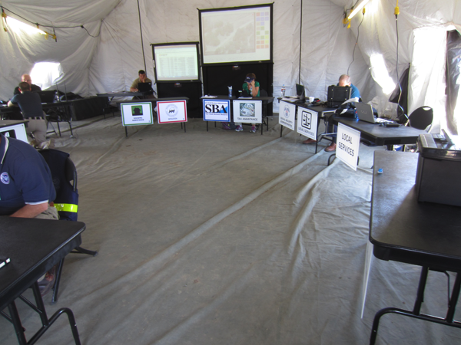
DRC data collection and workflow.
FEMA wished to explore the application of the design of the NYC Office of Emergency Management local recovery centers to the DRC, as well as explore some initial redesigns of the DRC performed by Frog Design on a pro bono basis. The hypothesis was that FEMA could significantly improve the user experience by combining three elements: 1) the use of color-coded signage in a circular layout, with agencies representatives sitting at each station in the workflow; 2) a concierge who would greet each survivor and guide them through the circle; and 3) tablet-based data entry.

In practice, the web-based systems being used to collect information about each survivor negated any improvements in the physical workflow. Survivors had to work with the concierge to enter data on 20 screens of web forms to get the registration number that other agencies would use in the process; this one step took well over 21 minutes to complete. As a result, the FEMACorps team and NPS worked out a simplified system to generate a registration number using Open Data Kit and Fulcrum, which could be completed in 3-5 minutes. Based on these results, FEMA will explore designs that more fundamentally rethink the interface between disaster survivors and federal services.

List of Related Experiments from NPS RELIEF AAR 13-03

FEMA Integrated Checklists for DRC Setup A-01
As part of the DRC redesign, FEMA began to develop a standard, integrated approach to set up DRC that is both easy to understand and use. The FEMA Individual Assistance Division (IA) worked on an integrated DRC checklist. IA reviewed the lists that different Regions have been using, researched other products and checklists, and developed a final draft. FEMA explored the usefulness of this checklist at RELIEF 13-03. Among the findings was that the materiel for the DRC was based on old processes, and needs to be rethought around new ICTs and workflows.
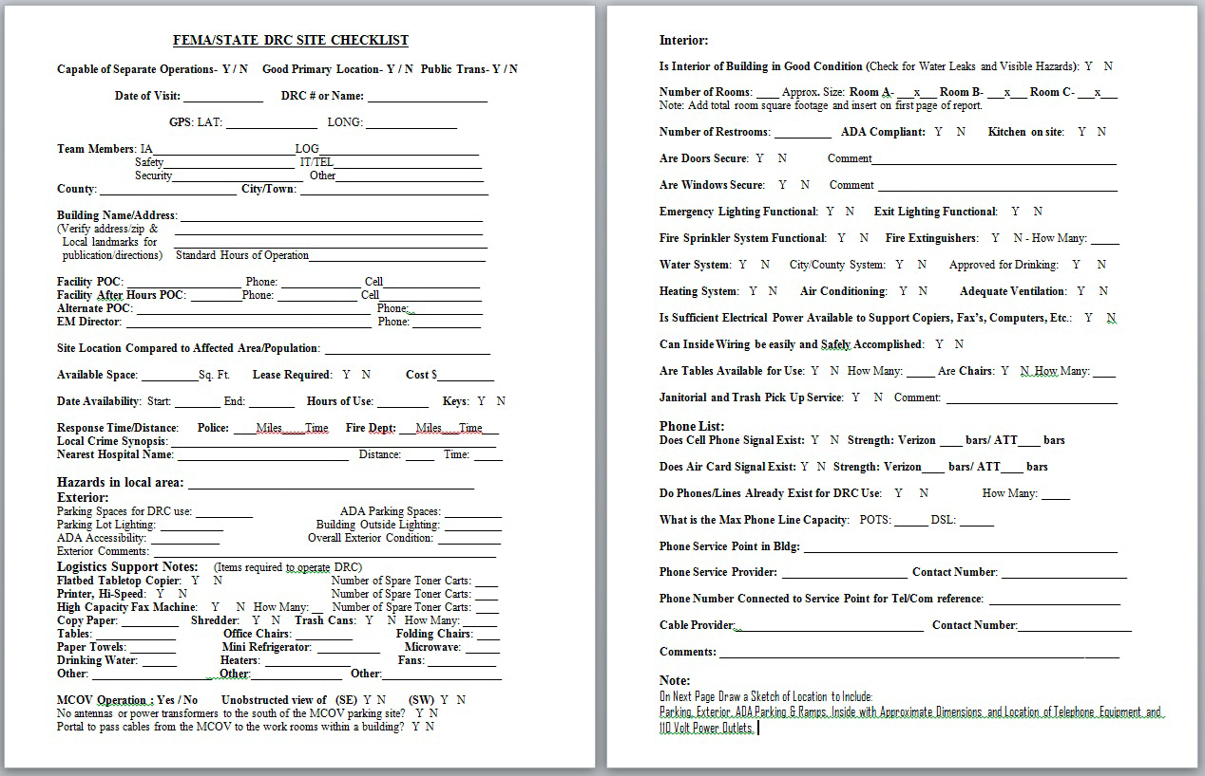

FEMA Process Flows for DRCs A-02
FEMA explored different business process flows (concierge, etc.) that are designed from the perspective of the survivor. These results from these explorations are not yet published. That said, the work scoped out designs for further work in August.

DRC Data Requirements A-09
FEMA explored data collection (such as forms), reporting, and situational awareness analysis requirements from DRCs, including requirements for the DRC itself, and to report to the next level of analysis, such as a JFO, the NRCC, etc. FEMA worked with FEMACorps and NPS to identify essential elements of information (EEIs) that could drive new thinking around data flows within and among DRCs. The EEIs are under review.

Mobile Data Collection – Spatial Networks B-07
FEMA demonstrated the ability of tools to operate successfully in a post-event field collection and mapping situation on a tablet device in both connected and disconnected environments. It also explored the real-time and fluid needs of responders to modify and adapt to field collection requirements and iterate on the logistics of revisions, deployment of updated apps, data feeds, and integration with visualization and analytical tools. The lessons from these explorations are summarized in the following blog post from Fulcrum: http://fulcrumapp.com/blog/fema-relief-experiments-at-camp-roberts/.

DRC Shelter
A problem in Sandy was the use of summer party tents during winter storms. They had neither the necessary insulation, stability, or HVAC systems to handle temperatures below freezing with high winds and wet snow. They also tended to be smaller than was needed to sustain an operation with multiple federal agencies under one roof. NPS invited HDT to help FEMA to explore how to alter its military shelters, which could quickly create a large covered area that could be insulated and would sustain operations in storm conditions. HDT set up an inflatable 32’x43’ tent as well as three successive smaller structures based on traditional pole frames. The prototyping of various workflows enabled FEMA to determine basic size for shelters as well as explore containerization of shelters for deployments. As a result, FEMA may explore shelters which integrate the shipping containers into the overall layout. Note that the experiment also exposed an unexpected benefit of air-framed tents: no attenuation of radio signals from the metal pole structures.

Other Experiments
Optimize to Reduce and Mitigate Data and Property Loss A-10
Protection for Mobile Equipment A-11
Risk Management Solutions and Practices A-12

Outputs for RELIEF 13-04
- DRC in a Box: the development of modular, scalable DRC designs that can be fit into shipping containers and rapidly deployed to an impact zone.
- Deconstruction of Survivor Registration: exploration of how much the survivor registration process can be simplified and modularized to speed the flow of survivors through DRCs.
- Solar/Renewable Power: explore sustainment of a DRC with as little supply chain as is possible.
- Local Disaster Cloud: explore the possibility of synchronizing local data with federal agency data centers using NSA-approved Ozone Framework, with potential for local data storage of geo data, registration data, and damage assessments (show a survivor the portfolio for a property)

Track 2: Equipping Mobile Disaster Survivor Assistance Teams (DSATs)

Framing Idea
Bringing services normally performed at the DRC to the doorsteps in an impact zone requires at least three areas of exploration: 1) procedures to combine DSAT services with damage assessments, 2) data collection protocols and tools that enable these new procedures, and 3) data and communications services that enable the data collection protocols. FEMA explored all three areas in RELIEF 13-03.

Individual Experiments

1. FEMA-Corps DSAT Teams
FEMA worked to develop procedures that link assistance to disaster survivors with damage assessment activities requires building teams which can function across disciplines. FEMA explored the possibility of using low-cost FEMACorps teams, which mobilizes approximately 1600 young adults (18-24 year olds) under the Americorps program of the National Civilian Community Corps (NCCC). This experiment examined what TTPs would be necessary to develop to deploy FEMACorps teams as DSAT teams. The working hypothesis was that a team could be provisioned with man-portable set of ICTs that would enable them to function as a dismounted DSAT team in a disaster impact zone. Two experiments centered on developing channels to communicating damage assessments and team status reports:

FEMA Tablet Configuration A-06
Devices, such as tablets and smartphones, are the key to providing survivor-centric services in a mobile environment. These devices need to be setup to work as best as possible, given the limitations of their operating system, to ensure successful interactions with survivors. The objective of this experiment was to produce a prototype for settings that contains all of the information a FEMA employee needs to provide one-on-one services to survivors in 1) an austere bandwidth environment; and 2) a robust bandwidth environment. The exploration revealed a number of challenges, including issues around Apple IDs needing to be linked to personal credit cards if not configured properly, and the need to perform a hard reset on the devices when the Apple ID is misconfigured with a credit card (wiping all configuration and requiring a complete from-scratch setup). The team also discovered that geographic information should be downloaded from a local (onsite) server rather than the Internet, even when office-grade WiFi is available due to the bandwidth demands of large files. Geographic information should also be limited to the area of interest of the specific operation. Additional summaries will be available through the NPS Technical Report.

FEMA Communications—Mobile Team Leadership A-05
The purpose of this exploration is to develop a standard approach to reporting team level progress and needs to the next level of leadership. The exploration used the DARS tablet application to collect reports from team members. The results are still under FEMA review at the time of writing.

2. Data Collection Protocols
FEMA explored tablet-based data collection protocols using three systems: the standard-issue DARS application that FEMA developed, Fulcrum, and the Open-Data Kit. FEMACorps teams explored how well DARS works in offline environments, as well as how to synchronize Fulcrum’s configuration with Open Data Kit configuration so that forms built by an NGO or agency using one application could synchronize their forms/data fields with others working in the same area. This configuration was a success.

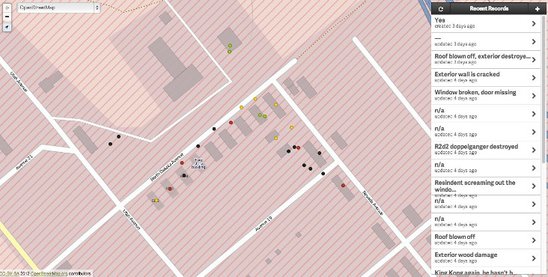
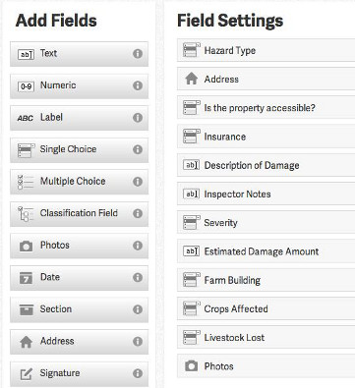

Experiment Listings:
FEMA Communications—Mobile Teams to DRCs A-04
Interoperable Communications – Lockheed Martin B-02
Mobile Data Collection – Spatial Networks B-07

3. DSAT ICTs to enable data collection
To collect field data requires bandwidth at some point in the cycle as well as basic team communications for coordination. FEMA explored several models for supporting small squads:
- UAV-supported aerial relays to enable land-mobile radios (LMRs) to operate over a 40-mile diameter cloud, so that DRC managers could interact with forward-deployed teams. Lockheed Martin Corporation (LMC) provided a Desert Hawk UAV to provide a high-endurance (8 hour) communications capacity for roving teams. The bird carried a Rifleman P25 radio that provided radio communications between McMillan airfield and the front of base (approximately 3-4 miles over hilly terrain). Lockheed drove a truck to test the capacity at 40 miles from the site and made successful links.
- Communications bridges that convert the inputs and outputs of LMRs, 2G/3G/4G cell phones, and VOIP/Skype into IP-based communications, so that all devices can interoperate. FEMA explored this method to bridge local authorities (Sacramento, CA 911 Dispatch) with the FEMACorps teams performing disaster assessments. They successfully had a 911 dispatcher from a Sacramento-based VHF system relayed over the Internet and the LMC Desert Hawk UAV to the UHF LMR radios used by the FEMACorps Team.
- Rolling WiFi Bubbles provided by support vehicles with local servers for synchronizing data collected from the tablets. Using a Suburban configured by Sacramento as a communications support vehicle, FEMACorps teams successfully collected data via a local wifi cloud. This model was a proof of concept that needs to be expanded with full synchronization of data in August.

The experiments related to the thread of inquiry are:

Extended Endurance Small Unmanned Aerial System – LMCO C-04
InstantEye First Responder ISR Support C-05
Baseline Network Requirements A-07
Optimize to Reduce and Mitigate Data and Property Loss A-10
Protection for Mobile Equipment A-11
Risk Management Solutions and Practices A-12

Outputs for RELIEF 13-04
The three explorations in combination provide a foundation for an integrated experiment in August, which would explore several areas:

- The direct connection of DSAT teams with remote mappers from the VTC communities like the Humanitarian OpenStreetMap Team. It would be technically feasible to allow remote mappers to perform damage assessments in coordination with field teams, adding building polygons to the map (potentially with pre-disaster information from municipal datasets). This connection could extend to radio communications, so that mappers on Skype could talk with DSAT teams over LMRs.
- DSAT teams could use imagery from supporting UAVs to allow a mapper in their support vehicle to add building polygons locally. The teams could then synchronize the base maps in their tablets periodically.

Track 3: Interagency and Inter-Government Communications

Framing Idea
Across the country, police and fire departments in adjacent towns have radio systems that fail to interoperate. During a national-level response, when state and federal agencies join the mix, communications breakdowns can still be expected. A core service that FEMA can offer is the ability to bridge usually incompatible communications systems. It can also offer data services to DRCs and communities affected by disasters. The third track of field explorations at RELIEF 13-03 explore interoperable, inter-agency communications supported by aerial assets.

Individual Experiments

UAV-supported Radio Relays
As mentioned above, LMC provided a Desert Hawk UAV to serve as a multiband airborne radio relay. At 2000 ft above ground level (AGL), the system provided a radio bubble over a 40 miles diameter.

UCP-bridging of incompatible radio systems
In conjunction with the Desert Hawk radio repeaters, the Universal Communications Platform (UCP) bridged VHF and UHF frequencies across a range of responder radios that were not known to LMC prior to arrival at the site. Sacramento was able to patch in their LMRs as well as the dispatch center back in Sacramento, along with PBX capabilities to tie in land-line phones. LMC also bridged 2G, 3G, and 4G cellular systems into a shared channel between VHF, UHF, and Skype devices.

The following figure summarizes this architecture:

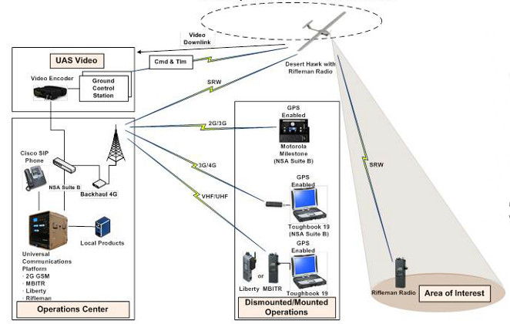

Outputs for RELIEF 13-04
Sacramento would like to explore the use of UAVs and UCP to bridge local, state, and federal agencies in the event of catastrophic failure of the levees that provide the San Joachim valley. Sacramento would like to have their dispatch tied into all communications and coordinating the local response with the state. This experiment would explore if the architecture is sufficiently simple to be deployable in Pelican cases and locally configurable.

Track 4: Situational Awareness and Information Fusion

Framing Idea
Decision makers are asking for better SA around citizen-generated data, including social media, data submitted over cellular networks via SMS. They also want to fuse data in ways that allow for real-time or near-real-time views of a situation. Several teams explored underlying issues with the creation of this SA: how to map where citizens can submit data over cellular networks and how to enable responders to securely use social media channels that are shared with the public.

Individual Experiments
Communications—Data Models to Provide Situational Awareness A-13
Cloud Computing for Disasters A-08
These two FEMA-led experiments focused on the integration of FEMA’s yet-to-be launched Disaster Cloud with the field data collection work happening with FEMA Corps teams. The results are still under review.

Encrypted Twitter – Ultra Electronics Prologic B-03
Like any snippet of text, Twitter messages can be encrypted. Ultralogic explored a framework for enabling FEMA teams to coordinate using this public social media channel with encrypted messages. The capability showed the bring-you-own-device is a possibility for FEMA staff who still need to maintain some degree of operational security.

Cellphone Signal Mapping
Cellphone Signal Mapping– Ultra Electronics Prologic B-04
Real-time Mapping of Mobile Network Coverage – FEMA Innovation B-05
Sensor Network for Mobile Coverage – Wireless Innovations B-06

Three experiments explored the capability of mapping the strength of cellular networks after a disaster. In the response to Sandy, one of the limiting factors for engaging the affected neighborhoods (and creating dialogue around their needs via social media) was the weakness of cellular signals. Although carriers provided cells-on-wheels (COWs) and cells-on-light-trucks (COLTs), the carriers did not provide a high-resolution maps of signal strength. As a result, FEMA had no aggregate map of where cellular coverage was and was not available on any given day. This set of experiments explored how to build this map using ground-based sensors on vehicles as well as airborne sensors on UAVs. The sensors included an app on modified Android phones. The results allowed for a network of breadcrumbs of sensor readings. What needs to be done in August and beyond is the development of hypothetical propagation of those signals in a heat map over an arbitrary area. According to the scientists and engineers, this model is currently a time-consuming analytical product to create (weeks). The objective of future experimentation will be to drive the time to collect, analyze sensor readings into this type of heat map down to useful time scales (hours).

Outputs for RELIEF 13-04
- Explore the use of the FEMA cloud product for synchronizing data from tablet devices with other data from FEMA operations, so that DSAT teams are feeding data into the system getting analytical products in return.
- Explore generation of heat (cloropleth ) maps of cellular coverage from an aggregation of sensor readings, including standard smart phones that might be configured for use by FEMACorps as well as the general public. These maps would be used

