8th Annual TIDES Technology
Field Demonstration
After Action Report (AAR)

Humanitarian Assistance/ Disaster Relief
Building Partner Capacity
Defense Support of Civil Authorities
Stabilization & Reconstruction
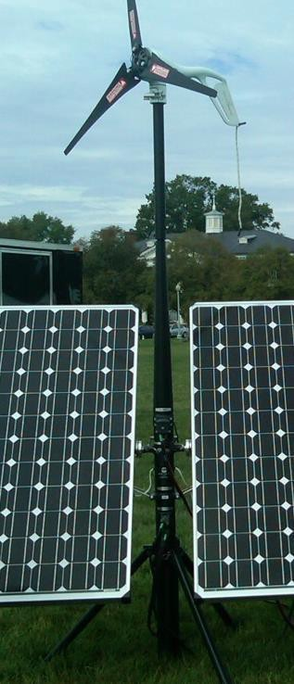

Stabilization and Reconstruction
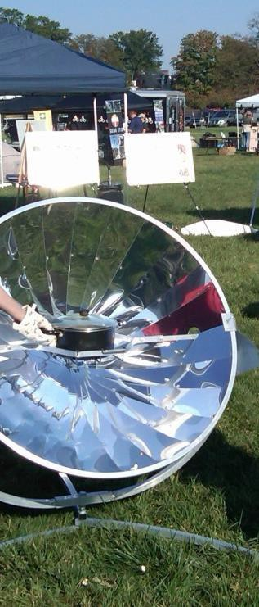

Humanitarian Assistance & Disaster Relief
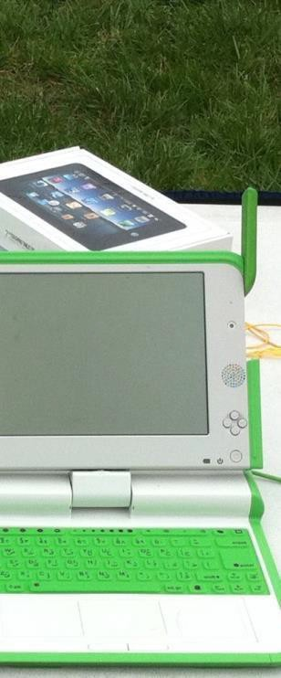

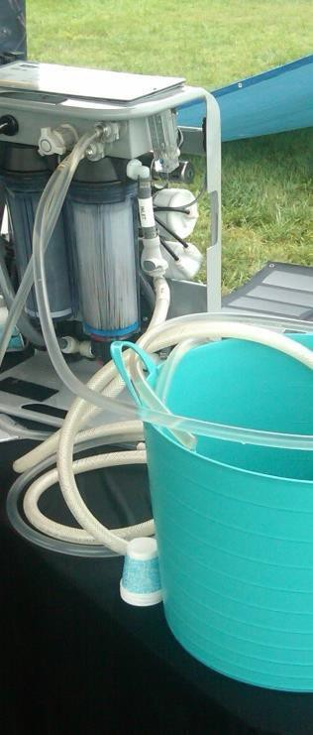

Defense Support for Civil Authorities {DSCA}

November 2014

TIDES (Transformative Innovation for Development and Emergency Support) is a Department of Defense research project dedicated to open-source knowledge sharing to promote sustainable solutions to populations under stress. It is coordinated at the Center for Technology and National Security Policy (CTNSP) at NDU.

Background
The TIDES Technology Fall Field Demonstration is held annually at the National Defense University Campus at Fort Lesley J. McNair. The TIDES Tech Demo seeks to enhance public-private partnerships with interagency, whole-of-society, and international activities. The technologies showcased deal specifically with low-cost, cross-cutting, rapidly deployable capabilities that populations under stress can use. Technologies are displayed across eight infrastructure areas: 1. Water, 2. Power, 3. Shelter, 4. Heating/Cooling, 5. Lighting, 6. Sanitation, 7. Integrated and Combustion Cooking, and 8. Information Communication Technology (ICT). Power for the event is created on site. Snacks are cooked using sun-heated ovens or, “solar cookers” and all communication technologies are demonstrated live via mobile satellite connection. The event is more of a science fair than a trade show; people attend more to show new ideas than to sell products. TIDES approaches support DoD missions ranging from pre-conflict initiatives that shape security environments and build partner capacity to post-war stabilization and reconstruction, to humanitarian assistance/disaster relief and defense support of civil authorities. The demo is widely attended by the Department of Defense officials; government agencies active in domestic and international disaster response and building partners in post-conflict, post disaster, and impoverished situations - DHS, FEMA, State Department, Red Cross, National Defense University students from around the world; as well as an array of private, for-profit and non-profit organizations.

The 2014 TIDES Tech Demo
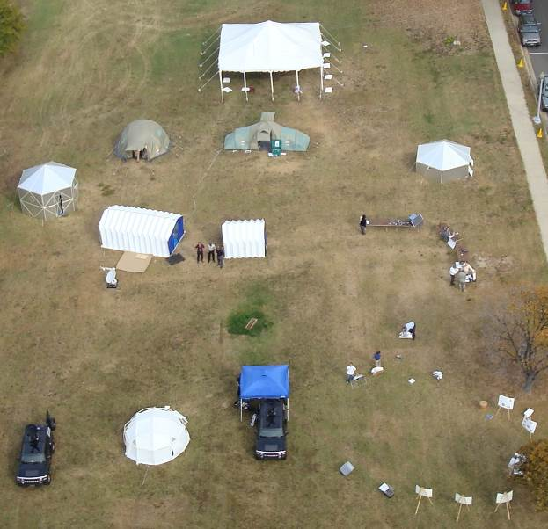
Over the last seven years, the TIDES Tech Demo has steadily grown in popularity. The event started in 2007 with a hand-full of visitors (See Figure 1) and is now the largest single event held at NDU each year. True to the mission of working across disciplines, TIDES partnered with the National Guard Bureau on the 2014 TIDES Technology Demonstration. The theme of this year’s demo was “Collaborate, Respond, Recover.” Latest numbers indicate that the 2014 TIDES Tech Demo had the largest number of registered visitors ever, ranging from two star generals to FEMA Corps volunteers, plus others who visited but did not register. This year during six days and two locations we had over 20 speakers, ranging from the Department of Homeland Security Undersecretary for Science and Technology to the organizers of Occupy Sandy, the NYC non-official response to Superstorm Sandy. This year there were more than 50 exhibits with 140 exhibitor representatives from more than 12 states. About five million dollars in innovative small-scale technology was demonstrated.
Figure 1: Aerial View of 2007 TIDES Tech Demo
Highlights from the 8th Annual TIDES Tech Demo
- Utilizing exhibitors to meet needs of the TIDES Tech Demo works. Starting with an empty field Monday morning, by 9:00 AM Tuesday we had:
    - 100% of the demonstration powered by five exhibitors with portable solar equipment. Solar Stik and Energy Solutions provided power for the TIDES tent and speaker tent independent of the power grid.
    - Demonstration of food, coffee and tea cooked in solar ovens and high efficiency stoves
    - The Hippo Water Roller Project and The Basilar Group worked together to transport and purify potable drinking water from the Potomac River for all attendees (See Figure 2)
    - GATR Technologies provided WIFI
    - Five exhibitors provided multiple options for shelter
- This year’s demo included stronger links to the National Guard Bureau, the Department of Homeland Security’s Science & Technology Directorate and the Federal Emergency Management (FEMA) Corps. (See Figure 3)

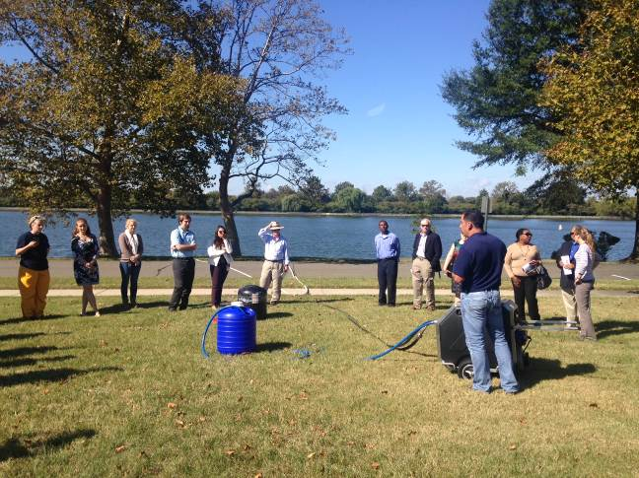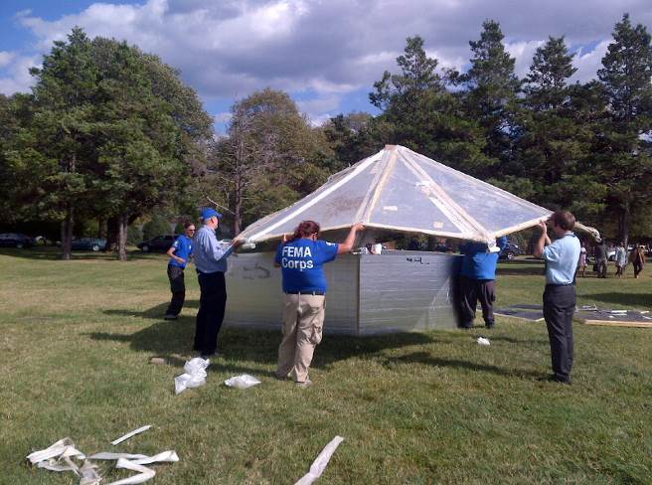
Figure 2 Hippo Water Roller & Basilar Group Demo Figure 3: FEMA Corps Volunteers

2014 TIDES Tech Demo Exhibitor List

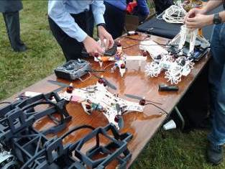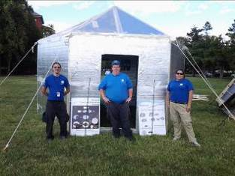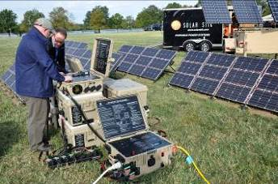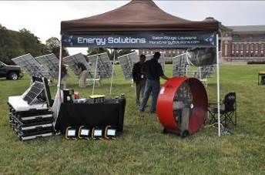
Infrastructure | Exhibitor | Website
Shelter | CTEK | http://actscsi.com
 | Decadome | http://decadome.com
 | Shelter Box | http://www.shelterboxusa.org
 | Visible Good | http://visible-good.com
 | Hexayurt
Power | Tiberius Energy | http://tiberiusenergy.com
 | Rugged Systems (Energy Technologies Inc.) | http://www.ruggedsystems.com/
 | Energy Solutions | http://energysolutions.com
 | Delta Electric: Delta Corp | http://deltaepa.com
 | Day and Night Solar | http://dayandnightsolar.com
 | Sirona Cares Foundation | http://www.sironacares.org
 | Solar Stik | www.solarstik.com
 | WorldWater & Solar Technologies Inc. | http://www.worldwatersolar.com
 | Eco Power Liberia | http://ecopowerliberia.com
 | Aspect Solar | http://www.aspectsolar.com
 | Solar Pure
 | Hybrid Pedals | http://www.hybridpedals.com
 | Delta Products Corporation | http://www.delta-americas.com
Water | Cardinal Resources | http://www.cardinalres.com
 | Aquasolve Ventures LLC | http://www.aquasolveventures.com
 | International Water Company | http://internationalwatercompany.com
 | EZ-Pack Water | http://www.ezpackwater.com/en/default.asp
 | Parjana | http://www.parjana.com
 | The Basilar Group | http://www.thebasilargroup.com
 | Mac Water Tech | http://macwatertech.com
 | Hippo Water Roller | http://www.hipporoller.org
Cooking | Solar Cookers International | http://www.solarcookers.org
 | California Sunlight Corporation | http://www.california-sunlight.com
 | Solar Household Energy | http://www.she-inc.org
ICT | Inmarsat | http://inmarsat.com
 | Christine Wireless
 | Lyman Communications | http://lymancom.com
 | NVIS Communications | http://nvis-barrett.com
 | GATR | http://gatr.com
 | Noblis NSP(GeoSHAPE) | http://www.noblis-nsp.com
 | Regula Forensics | http://regulaforensic.org
 | Van Cleve & Associates Inc. | https://www.vcasecurity.com
 | Knowledge Bridge International | http://knowledgebridgeintl.com
 | NiyamIT | http://niyamit.com
 | Thuraya Telecommunications Company | http://www.thuraya.com
 | WebFirst | http://webfirst.com
 | MedWeb | http://www.medweb.com/
 | Smart Imaging Systems, Inc. | http://smartimagingsystems.com
 | Disaster Solutions, LLC | http://www.disastersolutions.cc
 | DHS S&T Communications Support | http://www.dhs.gov
 | KSI Data Sciences | http://www.thelaunchplace.org
 | National Library of Medicine | http://www.nlm.nih.gov
 | Voxtec International, Inc. | www.voxtec.com
Sanitation | Ecovita | http://ecovita.net
 | Sanivation | http://sanivation.com
 | TerraMarCo | http://www.terramarsports.com
 | Toilets for People | http://toiletsforpeople.com/
Lighting | American Light Works | http://americanlightworks.com
Other | Laser Technology Inc. | http://lasertech.com
 | Waterous Co. | http://waterousco.com
 | Milspray | http://milspray.com
 | VT-ARC, VT DREAMS Lab | http://www.vt-arc.org
 | AmeriCorps NCCC FEMA Corps | http://www.nationalservice.gov/programs/americorps/fema-corps
 | First Line Tech | http://www.firstlinetech.com
 | Mobile Sciences Consortium

Speaker Series Highlights
In addition to showcasing sustainable technologies, this year’s event included speakers from across DoD, USG, academic institutions, and NGOs who spoke on this year’s theme, “Collaborate, Respond, Recover.” Speakers shared their insights on challenges we face in development and emergency response. Despite coming from a wide diversity of organizations, most speakers stressed similar themes. These clustered around concepts of emergence, the empowerment of grass-roots communities, the use of already-existing networks, and the need for government organizations to think in terms of partnerships with civil society, the private sector and NGOs. Speakers agreed on the need for agility in response and the use of appropriate technology. In particular they highlighted the utility of crowdsourcing, open source intelligence, geospatial data, and off-the-shelf technologies. At the societal level, there was consensus on the need to build community resilience, and appreciating that the people in the affected community were the immediate responders. Speakers also emphasized that we need to utilize pre-existing networks, many of which will be virtual. The obverse of these recommendations was the need to move away from the current paradigm of deliberate planning, big systems, etc. A short summary of speaker discussions is provided below.

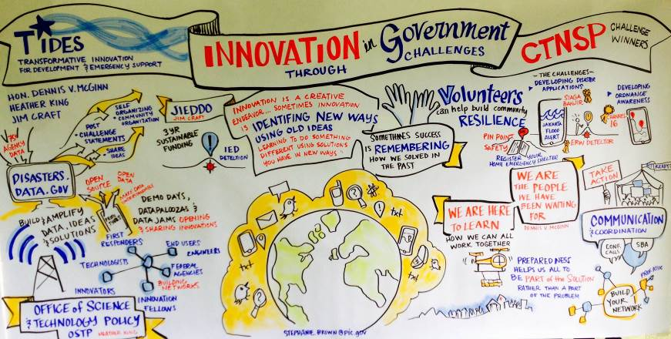
Figure 4: Visual Representation of Speaker Series by Stephanie Brown

National Guard Bureau Panel
Distinguished members of the National Guard Bureau (NGB) spoke to the role Guard members have played in local/international disaster relief missions. Speakers demonstrated the utility of having guard members working with communities in order to efficiently coordinate and execute disaster preparedness and relief plans. Furthermore, there was discussion regarding the various international relationships the Guard has created through the State Partnerships Program, which allows different states to partner with a foreign country to promote cooperation and coordination. Read more at: http://startidesnet.wordpress.com/2014/11/03/the-peace-tech-lab/

The Peace Tech Lab
Dr. Sheldon Himelfarb of the United States Institute for Peace talked about a new initiative at USIP: the Peace tech lab. This is an effort to address the question of how to use the Internet effectively to halt violence. Among the techniques he mentioned are using text messages and human monitors to provide warning of outbreaks of violence. He emphasized the utility of crowdsourcing to generate publicly available information. It is important to connect for speed and agility. He asked whether, given the magnitude of the challenge, do we need a Marshall Plan for today’s world? Other themes stressed were accountability, transparency, and bottom-up capability. Read more at: http://startidesnet.wordpress.com/2014/11/03/the-peace-tech-lab/

Private Sector Partnerships for Humanitarian Assistance and Disaster Relief
Panelists included Sarah Williamson, Protect the People (PTP) and Sam Bendett, TIDES
Protect the People is a network of consultants that provide civil-military and public-private education to a variety of organizations and companies. Williamson talked about private sector innovation and the role of NGOs. She stressed the importance of feedback loops to help adopt new technologies and noted that solutions should originate in the population. She argued that the military needs to shift from its current emphasis on large, expensive platforms and systems to small, lighter, and cheaper technologies. Sam Bendett discussed how discussed how DoD engages the nonprofit world and DoD’s role in public private partnerships. Read more at: http://startidesnet.wordpress.com/2014/11/03/the-peace-tech-lab/

Innovation in Peacekeeping Technologies: A Demonstration for UN Operations
Dr. Walter Dorn’s discussion focused on the use of simple technology, as a means to provide peacekeepers with helpful tools to aid with humanitarian assistance and disaster relief. Some of the technologies he demonstrated were actually children’s toys. He displayed baby monitors, motion-triggered lights, an iPad controlled robot, and an iPad controlled quadcopter. While audience members questioned the utility of such simple technology in disaster zones, Dr. Dorn emphasized that these technologies could provide the United Nations and other organizations the necessarily tools to make a difference for stressed populations.

Innovation in Science & Technology
Dr. Reginald Brothers, DHS Undersecretary for Science and Technology discussed the technology research being done within DHS. He stressed that while resources are declining, the threat space is increasing. Therefore we must innovate to close the gap. He emphasized the power of co-creation of users and producers and urged a focus on user-centric innovation and that we should strive for hyperconnectivity. He also noted the importance of building resilient communities and disaster-proofing societies. While Dr. Brothers was not necessarily speaking directly to Humanitarian Aid and Disaster Relief he was tacitly underpinning the need for initiatives that involve a broad community, quick and efficient decision makers, and dialogue between citizens, distressed populations, and the science and technology community. Read more at: (See Figure 5)

Occupy Sandy Panel:
Panelists included Isadora Blachman-Biatch, Shlomo Adam Roth and Devin Balkind. Blatchman-Biatch, a Senior Associate Analyst at Homeland Security Studies and Analysis Institute, stressed that e-networks of activists are already in place and can be mobilized in disasters. She discussed how we could use social media to focus resources where they are needed with precision. It is possible to mobilize large numbers of people without creating hierarchical leadership structures. Instead, affected populations will use mutual aid rather than charity from outside agencies. Schlomo Roth and Devin Balkind stressed the use of Internet technology along the lines of an Amazon wedding registry: people can post information on what they need, and other people can provide it at the right time and place. Many of these technologies for communicating and providing needed stuff were tried out in the Occupy Wall Street protests. They provide a good model for network-centric DR operations.

Breakthrough Technologies for Disaster Response
Panelists included Abi Weaver, American Red Cross and John Crowley, Harvard Humanitarian Initiative and the World Bank. The discussion addressed how researchers and activists collect data that is not efficiently utilized in order to make the best, rational decisions. John Crowley talked about the need for systems to work well together. He stressed the need to collect and analyze data and use it to make informed decisions. We have devoted a lot of effort to developing sensors; now we need to spend more effort on analysis and on developing effective decision-making aids. We need to explore the potential of crowdsourcing. To make all this work we need to open up government data and to fuse data together. Abi Weaver noted that many open source tools are available. She stressed the importance of seeking needs based and human-centered solutions and building robust community systems. She said we need to think about technologies that increase resilience, such as wearable sensors, affordable 3D printers, UAVs, simple robots.
Read more at: http://startidesnet.wordpress.com/2014/10/15/too-much-data-not-enough-sense/

Innovation in Government Through Challenges
Panelists included The Hon. Dennis V. McGinn, Assistant Secretary of the Navy - Energy, Installations & Environment; Heather King, ‎Director for Preparedness Policy, National Security Council Staff, Jim Craft, Deputy Director for Information Enterprise Management and Chief Information Officer. Heather King talked about national preparedness efforts, noting that in the wake of Hurricane Sandy people in the private sector said that they wanted to help, but were unsure of how to do so. The issue is how to tap in usefully without redundancy. She talked about the use Microsoft and Google in this regard. Jim Craft’s central point was that we solve problems through creative human endeavor, not just through the introduction of new technology. Often, remembering old stuff and applying this to a new problem is the right approach. He emphasized that organizations don’t innovate; people do. Innovation doesn’t necessarily produce success: we need to apply new technologies properly. Hierarchical structured systems not good at innovation.
Lastly, The Hon. Dennis McGinn noted that people on the ground can be victims or they can be part of the solution. He stressed that DOD needs to think about how to operate with the people already on the ground to figure out ways to support local organizations and be a better partner. More broadly, we should try to make communities and nations more resilient. Noting the gap between the appearance of a crisis and the arrival of government, he emphasized that the local community is the immediate responder. It’s all about the people. During this panel winners of the CTNSP Disaster Apps and ERW & Land Mine Reporting Apps Challenge were also recognized. Read more at: http://startidesnet.wordpress.com/2014/10/15/fostering-innovation-and-preparedness-the-people-are-the-solution/ (See Figure 5)

Introducing Technology into Traditional Societies
This panel featured real-world examples from TIDES Demo exhibitors and attendees on introducing new technologies into traditional societies.

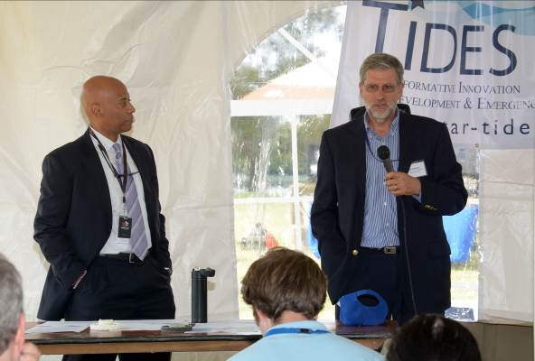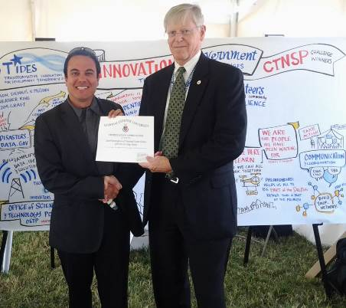
Figure 5: Speaker Series Snapshot (On the left Dr. Brothers, DHS Undersecretary S&T and
David Becker, TIDES Director) (On the Right Jacob Birmingham, 3rd Place winner
of Disaster Apps, with Dr. Dennis McBride, CTNSP Director)

Exhibitor Feedback
- Overall, exhibitors had overall positive impressions and were satisfied with the high quality visitors that attended the TIDES Demonstration.
- There were more contractors than military personal which meant a better chance of selling their products.
- Exhibitors find TIDES to be a more meaningful learning experience than other trade-shows.
- Exhibitors found TIDES Demo useful for promoting their technologies, exchanging business cards, and building relationships with other exhibitors to foster collaboration.
- Exhibitors find TIDES technology demonstration useful as a means to create meaningful relationships and sustain collaboration and innovation.
    - Solar Stik has been participating in the TIDES demonstration for years and has been able to connect with groups like GATR which has allowed them to foster a lasting relationship that has helped both build better sustainable technologies.

- Exhibitors develop connections with individuals and organizations that can and will utilize their technologies.
    - Inmarsat was able to link with other vendors thus gaining valuable feedback about the efficacy of their product. During the Pentagon Demo they were approached by the US Marine Corps and they hope to maintain this connection and work with the Marine Corps to develop a product that fits their current needs.
    - Energy Technologies Inc. gained valuable exposure and was approached by the Under Secretary of Defense for Acquisition, Technology and Logistics. They made connections via TIDES and are exhibiting their technology at the Army Research Lab’s live demo.
    - Toilets for People finds TIDES to be an excellent networking opportunity that allows for the exchanging of business cards and connections with visitors not necessarily affiliated with NGO’s in which Toilets for People generally pitch to.

Suggested Improvements
- Exhibitors would like to see more vendors and new faces circling TIDES.
- Find deals or discounts with local hotels as a means to attract exhibitors.
  - Though the quality of attendees was good, increase in advertising to bring in more visitors.
  - Exhibitors would like concrete information on the requirements and procedures for military and government funding and contracts.

Visitor Feedback
- Most visitors were either slightly familiar or completely unfamiliar with TIDES and thus
found information very informative.
- When asked if they would return to the TIDES demo next year most visitors responded they would be either extremely or moderately likely.
  - Visitors ranged from being very familiar with TIDES to completely unaware of the project and thus the TIDES demonstration fostered new contacts while also reconnecting with old ones.
  - Enjoyed seeing the awards presentation and learning about what these innovators accomplished.
  - Many enjoyed the graphics and storyboards by Stephanie Brown (@stephscribes) during the Speaker Series

Suggested Improvements
- More exhibits focused on “whole of society” disaster preparedness, and assessment technologies
- Bring in more organizations that have developed technologies for tracking and assessing compliance with the key Sphere standards.
- Increase presence of solar cooker displays
- Most visitors found the panels and facilitated discussions highly informative however they suggested speakers were merely scratching the surface of the issues and topics regarding humanitarian assistance and disaster relief.
- Consider changing the location of the TIDES Tech Demo to a venue where civilians and aid workers can easily access.
- Link the “theme” of the demo to actual requirements the Services and COCOMs have

